For Immediate Release:
Contact: Karen Pasquale, Mayor’s Office
Tel: (914) 422-1411
kpasquale@whiteplainsny.gov

WINTERFEST DOWNTOWN HOLIDAY MARKET
4 Day Outdoor Market to Offer Unique Holiday Shopping Experience
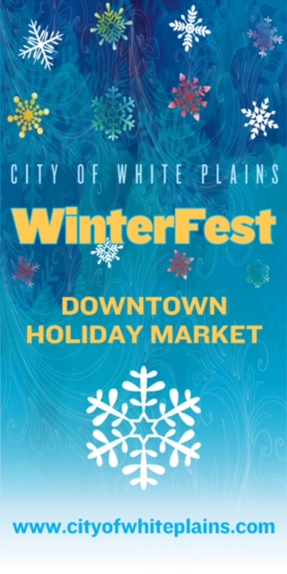
WHITE PLAINS, NY – December 1, 2017. It’s time to check your holiday shopping list and head over to WinterFest, White Plains’ downtown holiday market. Enjoy some holiday cheer and a special shopping experience. Pick up unique gifts for all the important people on your list.

WinterFest, presented by the City of White Plains and Bensidoun USA, kicks off on Wednesday, December 20th and runs through Sunday, December 24th. The Market will be located on Court Street between Martine Avenue and Main Street (the same location as the Farmer’s Market) and will be open Wednesday and Thursday from 11:00 a.m. to 7:00 p.m., Friday and Saturday from 11:00 a.m. to 9:00 p.m., and Sunday from 10:00 a.m. to 2:00 p.m. Admission is free.

The event will feature artisans and crafts people selling one of a kind items... Discover high quality food, unique gifts and more. Winterfest promises to be a great way to complete your holiday shopping while also enjoying music and dance performances scheduled throughout the duration of the market.
(More)

WinterFest is modeled on the holiday markets found throughout Europe that bring communities together with festive music, food, and gifts and help usher in the holiday season as a meeting place for friends and family. It is our goal to extend that tradition to downtown White Plains and create an atmosphere of cheer as well as a friendly holiday gathering place.

Here are some of our participating vendors:

This year’s market will feature Christmas wreaths, centerpieces, and natural holiday decorations from Westchester Greenhouses & Farm.

- Jar Worthy. Custom blended soy candles.

- Wild Sea Salt. Natural sea salt & seasonings. Special feature: cooking demo on 12/20 from 12:00 p.m. to 2:00 p.m.

- Loola Doola Boutique. Signature bags, jewelry & scarves

- The Sweet Ampersand. Hand lettering & calligraphy

- Room to Create. Art gallery & handmade mandala cards

- Praline et Chocolat. Chocolate creations

- Pane di Oro. Bread & Muffins

- Mind, Body & Bath. All natural skin care & soap

- Hudson Valley Chocolate. Handmade chocolate & caramels

- Crowne Plaza Coffee Shop. Gluhwein, traditional mulled wine, and delicious food

(More)

- Beth Russo Jewelry. Custom made jewelry

- Teagevity. Organic tea & tea gear

- Origami Owl. Customized jewelry

- Little Tibet. Shawls & scarves

- The Twisted Branch. Olive oil, vinegar, spices, honey

- The Twisted Branch / Crepes & Waffles. Hot chocolate, coffee, tea, crepes, waffles

- Vivian’s Jewelry. Handmade jewelry

- Julie’s Vintage 1. Vintage gifts & jewelry

- Julie’s Vintage 2. Vintage Christmas decorations

- Garden of Chrystals. Minerals, rocks & amber gemstones

- Conte’s Seafood. Fresh oysters for sale

- Russian Winter. Russian holiday ornaments

- Meredith’s Bread. Bread & baked goods, including a line of gluten free products

- Little Germany. German holiday decorations, Christmas cards, and ceramic holiday ornaments

WinterFest will also offer prepared food. Come for lunch, dinner or dessert!

(More)

Also be sure to check out our cooking demo’s:

~ Wild Sea Salt with Chef Lisa Caccamise will conduct a cooking Demo on Wednesday, 12/20, 12:00 -2:00 p.m. Recipes include: Pan seared fish with sumac wild sea salt paired with a stir-fry of seasonal vegetables with dandelion wild sea salt.
~ White Plains Education & Training Center Chef Joe Brefere (owner of Joe's BQ) will conduct a cooking Demo on Thursday, 12/21, 11:00 a.m. – 2:00 p.m. Recipes include: Filet Mignon & Horseradish Crostini with Micro Arugula and Sweet Red Pepper.

~ Break Bread Not Hearts will conduct a cooking Demo on Saturday, 12/23 at 5:30 p.m. Giovanni Chef D’Amour Green will focus on dishes that remind us of the tastes that are intertwined with the traditions of our various cultures with Love as the main ingredient. Free 30 minute class. There will be a sign-up available as the number of spaces for participants is limited. To reserve your space please email amour@breakbreadnothearts.com or winterfestwp@gmail.com

The City of White Plains would like to acknowledge and thank the White Plains Business Improvement District, The Westchester – A Simon Mall, and Party Line Rentals for their support and sponsorship of this event.
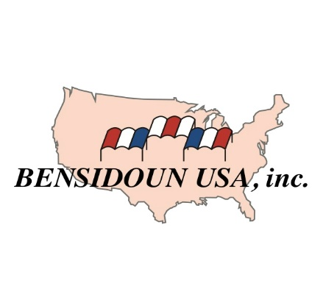

About Bensidoun USA.
Bensidoun USA manages the City of White Plains highly successful seasonal farmer’s market. Bensidoun USA has successfully expanded the number and variety of vendors at the market as well as extended the market season. Bensidoun USA manages 20 outdoor markets throughout the Northeast and Midwest. The company has over 60 years of experience and manages over 100 outdoor markets throughout the world. http://bensidounusa.com/

Follow Winterfest on Facebook: https://www.facebook.com/WinterFestMarket/

# # #

